**Microtask 1:** **Make an edit request and write about it**.

Following is the process of editing page:

1. Search any topic as your interest in google. And go to website.



1. So, now make a new account in Wikipedia. You can find create account button in top right corner. Or you can simply Log in if you have already had an account. **Note: you need account only if you want to publish your edit**.

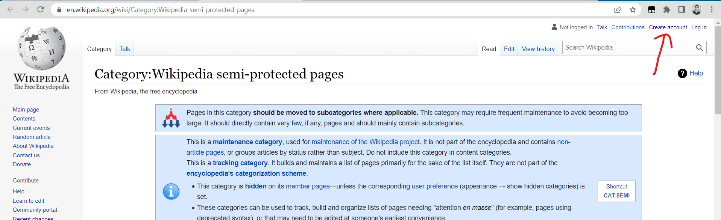

1. Now you need to tap edit source button available in right side of navbar.

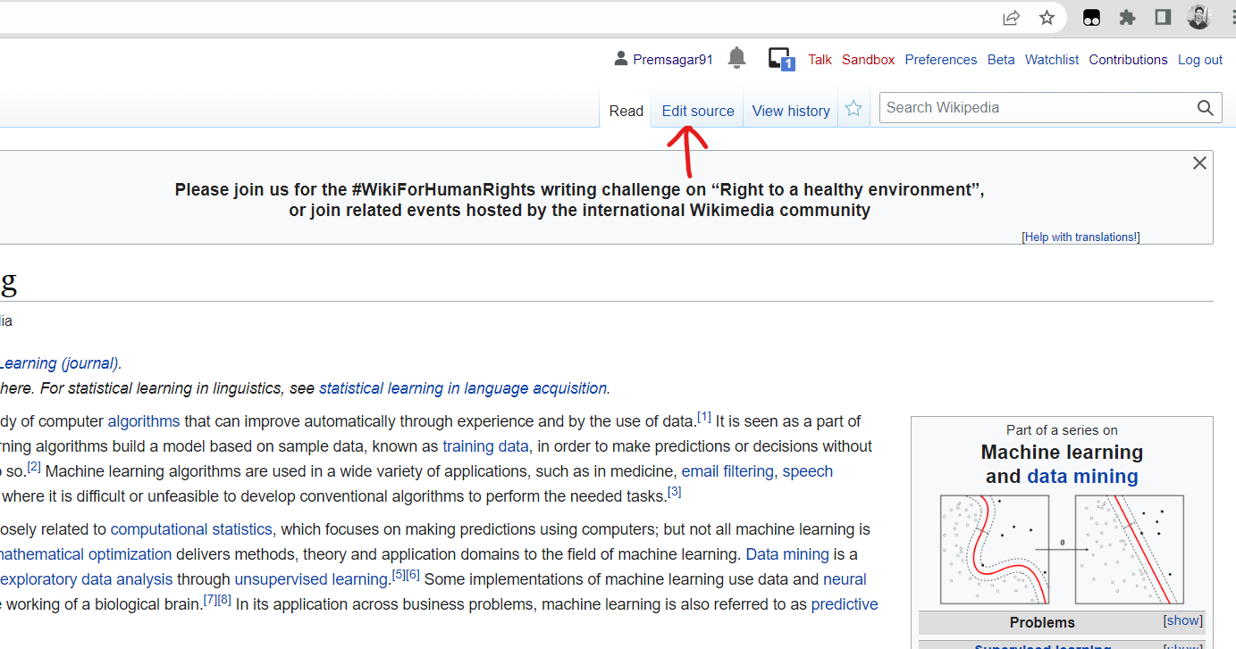

1. Now you will see source editing page where you can edit the content. Basically, Wikipedia provide two ways to editing first one is **source editing** and another is **visual editing.**
2. **Source editing**

You can change it to visual editing by tapping pencil button in right corner of editor.

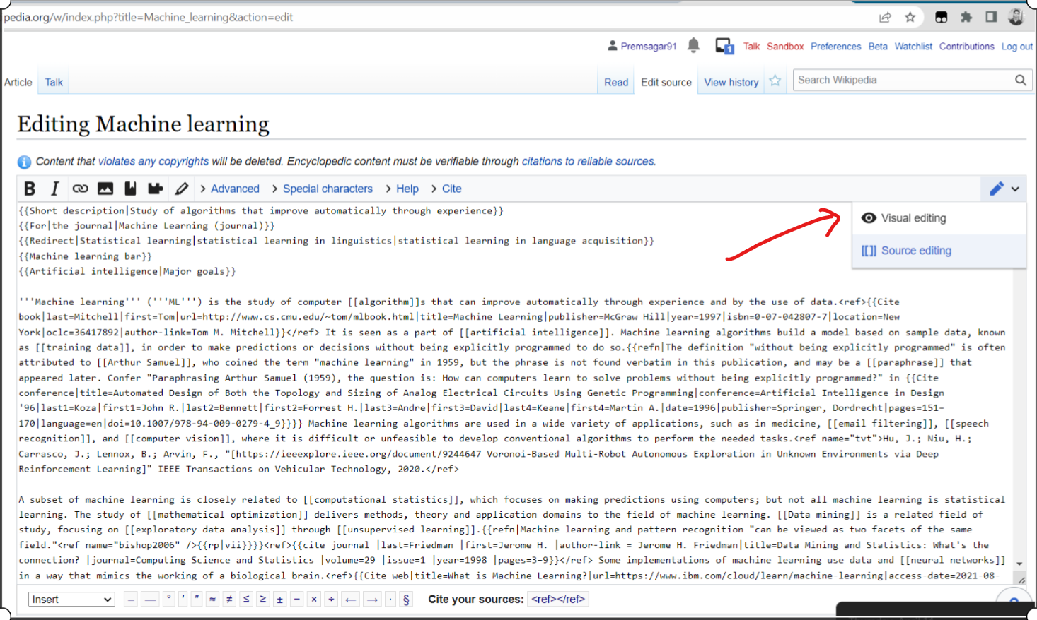

1. **Visual Editing**

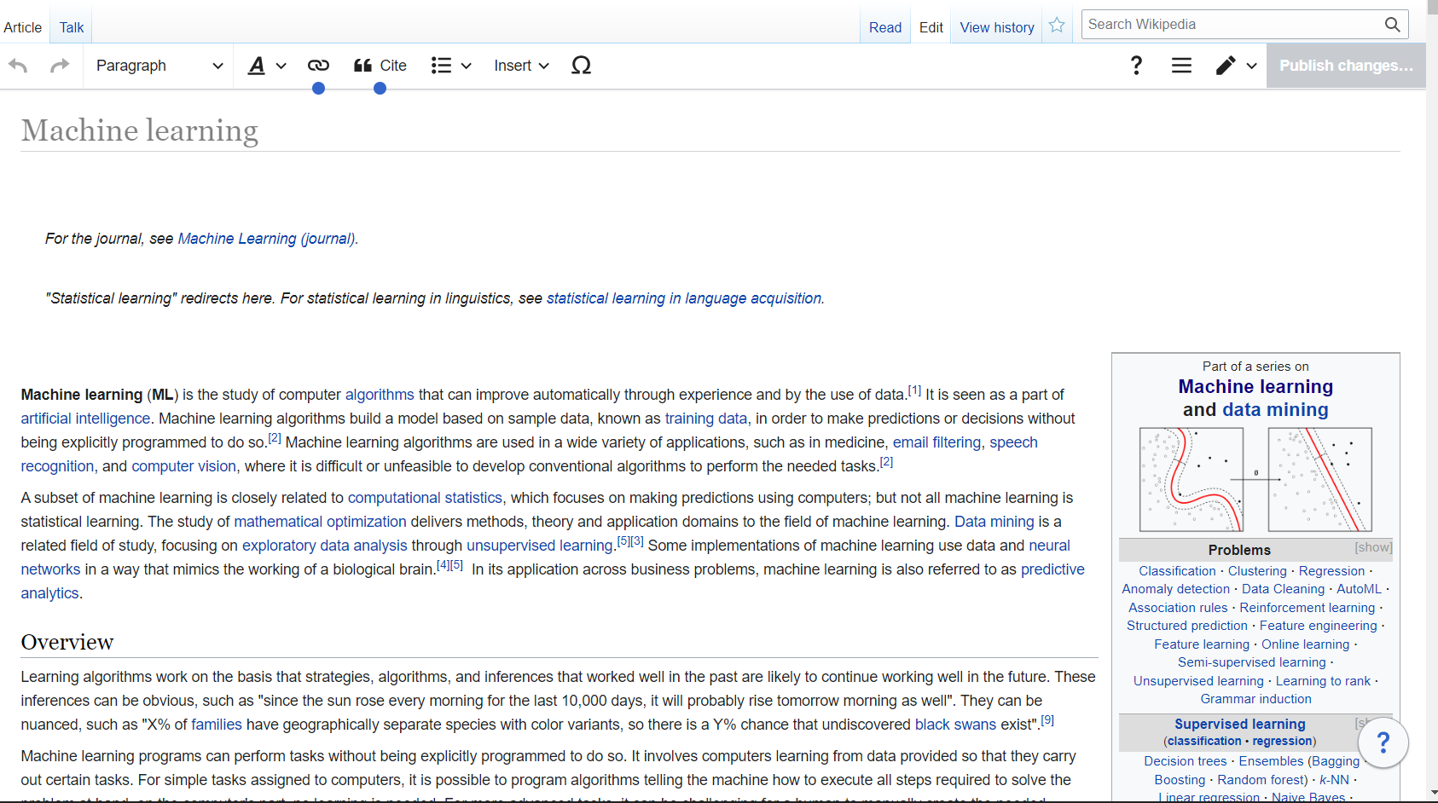

1. Now, let’s make some change in article. After editing we need to press publish change button available in right corner.

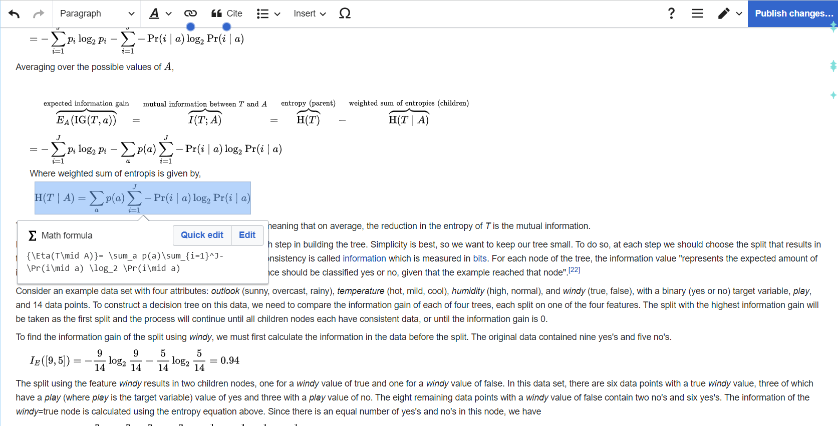

1. Now pop-up window will appear here you need to describe your change.

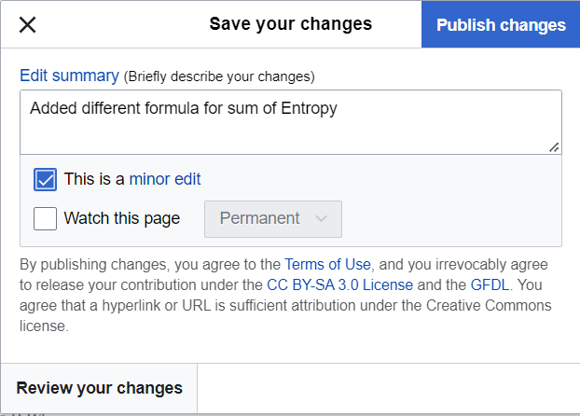

1. Review your change and click publish.

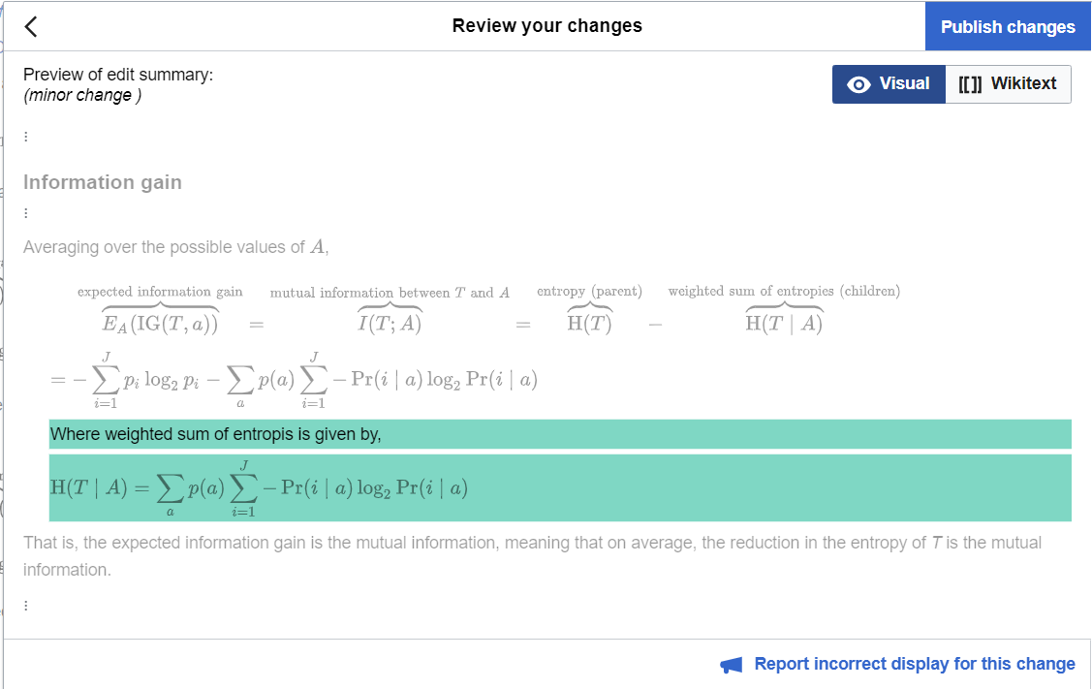

1. My changes link: -

<https://en.wikipedia.org/w/index.php?title=Decision_tree_learning&diff=prev&oldid=1082660125>

and article link: -

<https://en.wikipedia.org/wiki/Decision_tree_learning>

1. Some pages are protected and you can not edit directly but you can submit request for edit if your proposal is valid then they will make change on this.

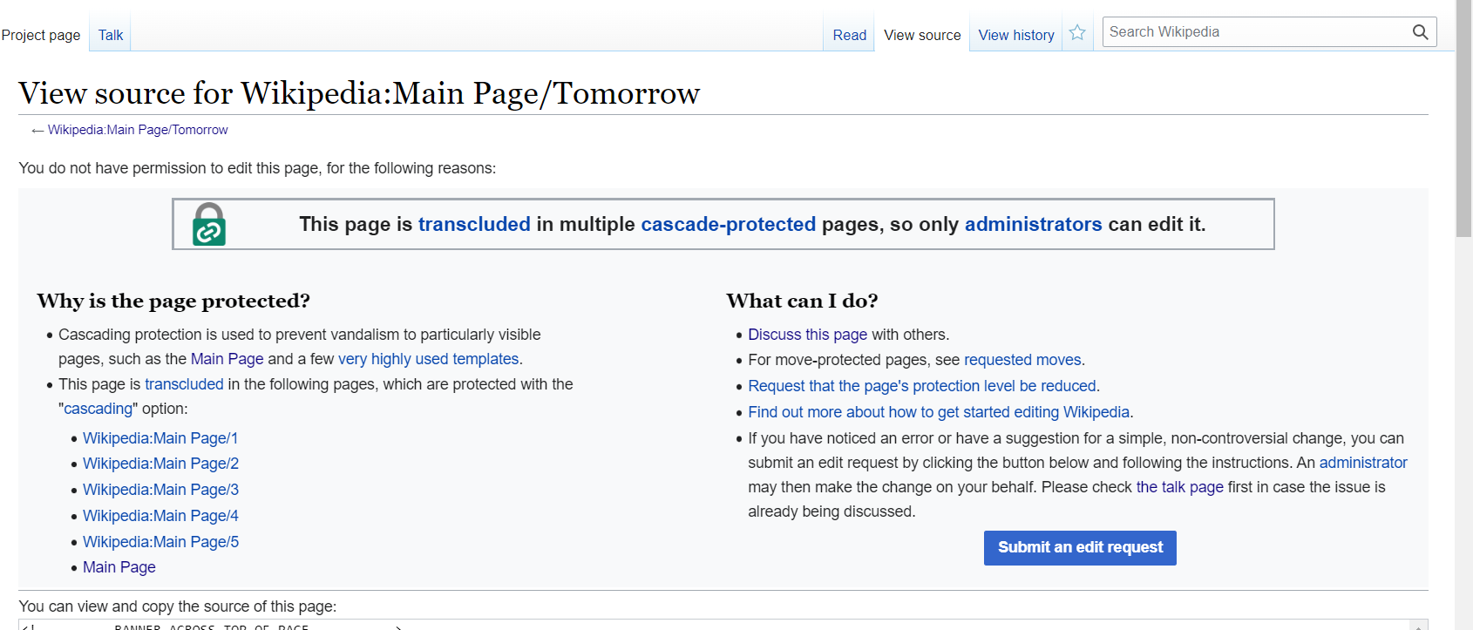

* 1. Before submitting request, you need to submit request in talk page.

